Head Men’s Basketball Coach Jeremy Esry would like to invite you to the Pirates Summer Basketball Camp at the Ketcham Community Center on the Campus of North Central Missouri College. All sessions will have an emphasis on fundamentals and becoming a better basketball player while having FUN in the process. The Camp will be run by Coach Esry, Assistant Coach Eric Penrod as well as area High School and College Coaches.
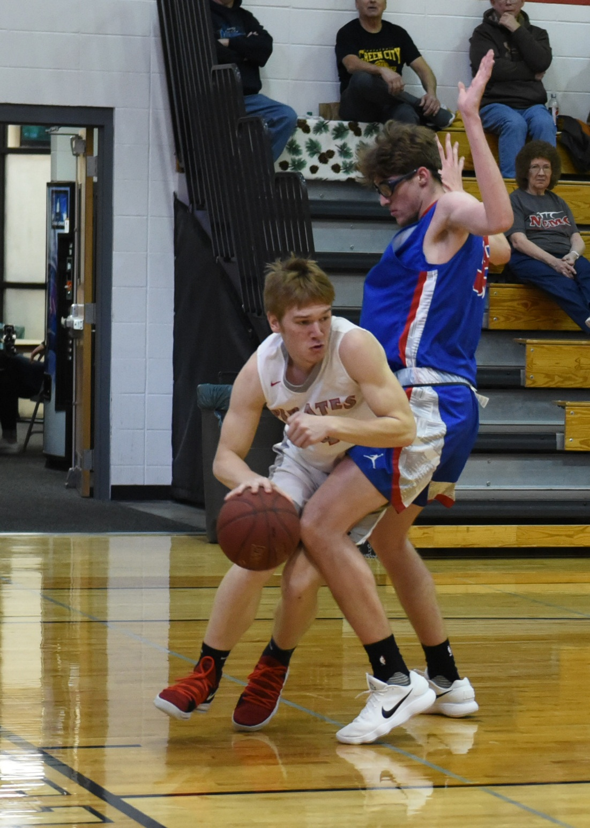
Grades 7th – 12th
1:00 – 4:00pm
July 22nd – 24th
$60

Grades 1st – 6th
9:00am – 12pm
July 22nd – 24th
$60

Men’s Basketball Summer Skills Camp
Send Registration form and payment to:
Jeremy Esry – Men’s Basketball
1301 Main Street
Trenton, MO 64683
For questions or more info: 816-465-0185 or jesry@mail.ncmissouri.edu

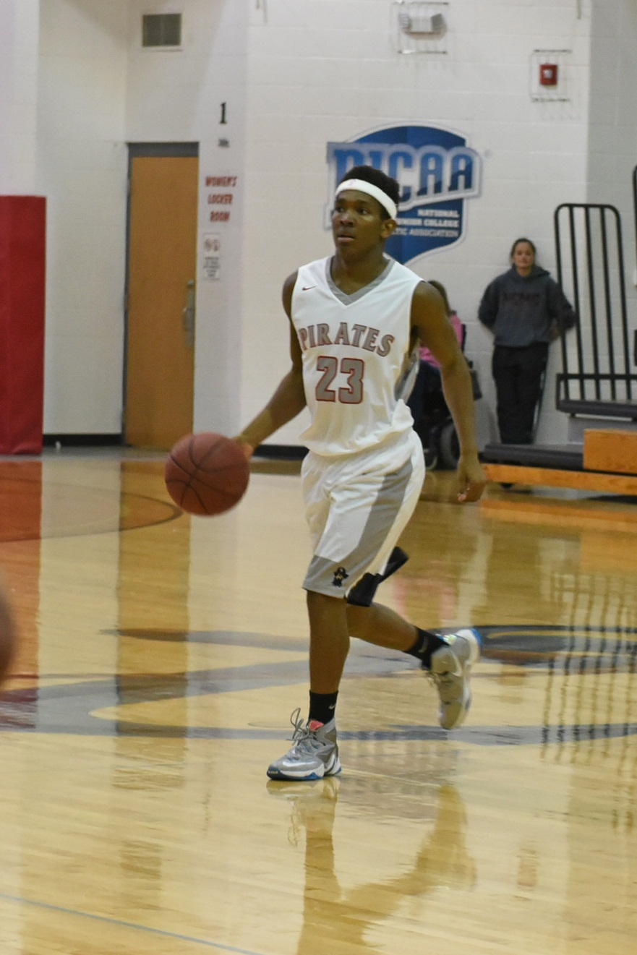
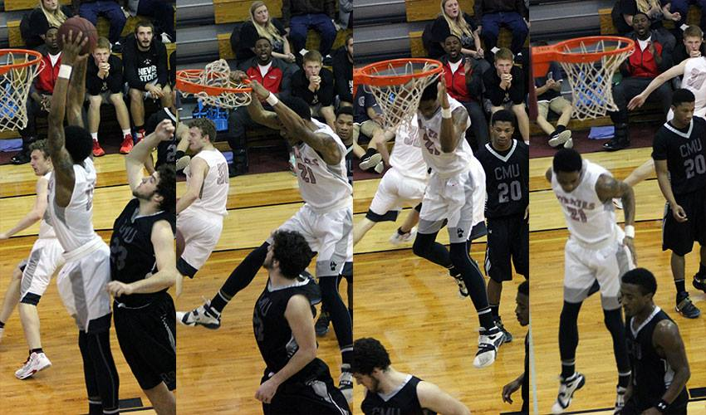
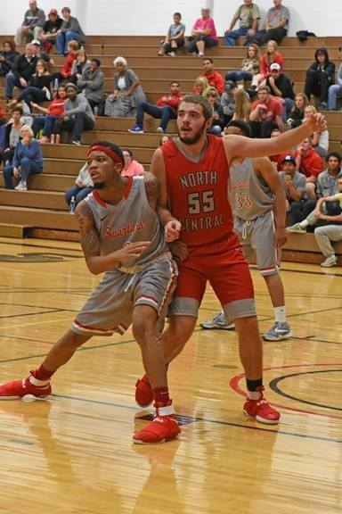
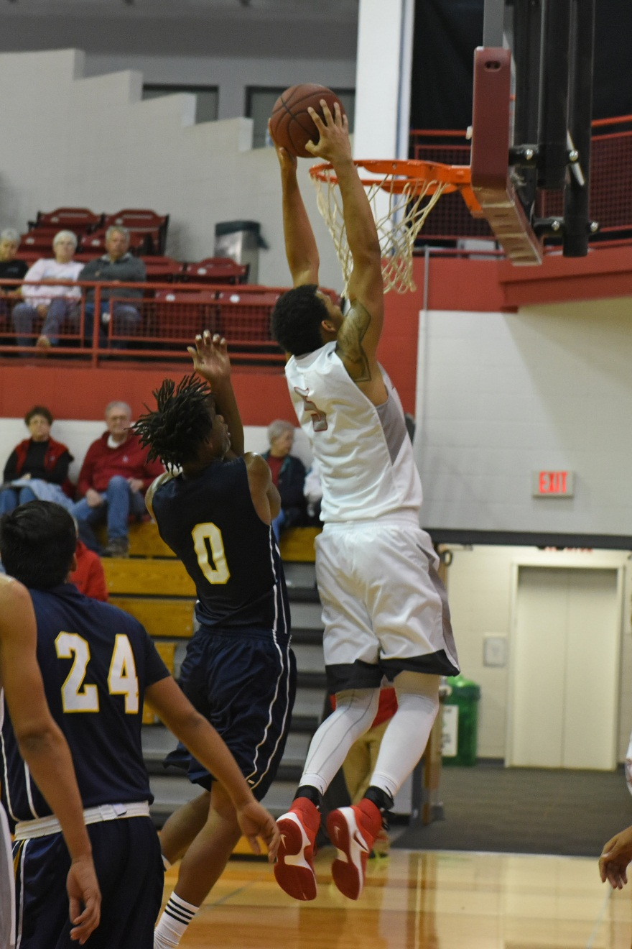

-------------------------------------------------------------------------------------------------------------------------------------------------------------
2019-2020 School Year (Circle One): 1st-6th grade 7th-12th grade
Player Name ______________________________ Age _________ Grade for 2019-2020__________ T-Shirt Size__________
Address ___________________________________________
City __________________________ State _________ Zip ____________
Parent/Guardian _________________________________ Cell # ___________________________
Parent/Guardian email ____________________________________ Daytime Phone # __________________________
Emergency Contact _____________________________ Emergency Contact # ____________________________
Parent/Guardian Signature _____________________________________________ Date __________________

